**NAME: CLINTON ARANI OMARI**

**REG NO: EB3/56416/21**

**ACSC 435: HUMAN INTERFACE DESIGN**

**Exercise 2: Individual Work - *Uniconnect* Project**

Here’s my response based on the provided instructions for fourth project:

**(a) Identify the interaction styles that you will incorporate in your interface. Justify/give reasons why you will select each of the styles.**

**1. Direct Manipulation**

* **Use Case:** Users interact with calendars, event timelines, or drag-and-drop for scheduling tasks.
* **Justification:** Provides a visual and intuitive way for users to manage events, reducing cognitive load.

**2. Menu Selection**

* **Use Case:** Navigation bar with options like "Home," "Events," "Messages," and "Profile."
* **Justification:** Simplifies navigation by presenting a structured list of choices.

**3. Form-Fill-In**

* **Use Case:** User registration, login forms, and event creation.
* **Justification:** Ensures users input structured data while providing validation and guidance.

**4. Natural Language Interaction**

* **Use Case:** Chatbots or search functionality allowing users to ask questions or search events.
* **Justification:** Enhances accessibility and usability for non-technical users.

**(b) Identify the user interface design features/characteristics you will consider to implement in your project design. Give your justifications/rationale based on the need to address the following usability attributes**

**i. Time to Learn**

* **Feature:** Onboarding tutorial and tooltips for first-time users.
* **Justification:** Reduces the learning curve, allowing users to quickly understand the interface.

**ii. Retention Over Time**

* **Feature:** Consistent design patterns and standard iconography.
* **Justification:** Familiarity aids users in retaining knowledge and skills over extended periods of non-use.

**iii. Error Rate**

* **Feature:** Real-time input validation and undo functionality.
* **Justification:** Helps prevent errors and provides users with a way to easily correct mistakes.

**iv. Speed of Operation**

* **Feature:** Keyboard shortcuts and predictive search.
* **Justification:** Speeds up navigation and task completion, especially for power users.

**5. Subjective Satisfaction**

* **Feature:** Customizable themes and a responsive design.
* **Justification:** Ensures the interface is aesthetically pleasing and adaptable to user preferences, enhancing satisfaction.

**(c) Prototype your UI design and take a few screenshots to illustrate your priority user interface design features implemented.**

As part of my fourth-year project, I have developed and prototyped a user interface (UI) for the Uniconnect Project. Below, I outline the key priority UI features implemented and include screenshots to demonstrate their functionality.

1. **Login/Registration Page:**

**Feature:**

* A clean and intuitive form-fill-in interaction.
* Includes real-time validation for user inputs, such as ensuring proper email format and strong passwords.

**Justification:**

* Provides a straightforward and structured method for users to create accounts or log in, aligning with usability attributes such as **time to learn** and **error rate** reduction.

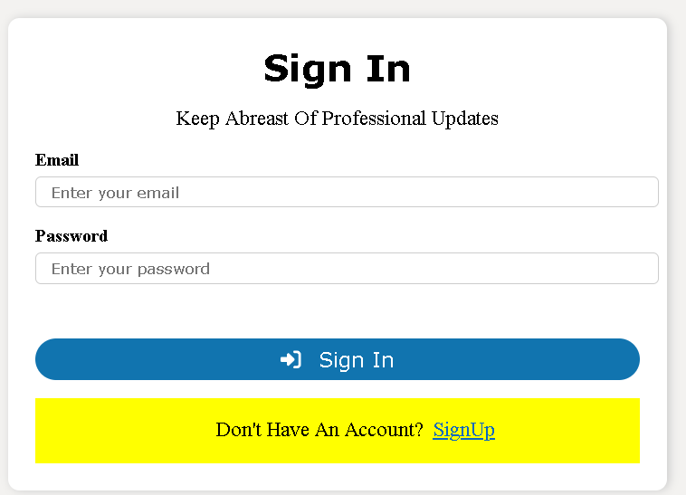

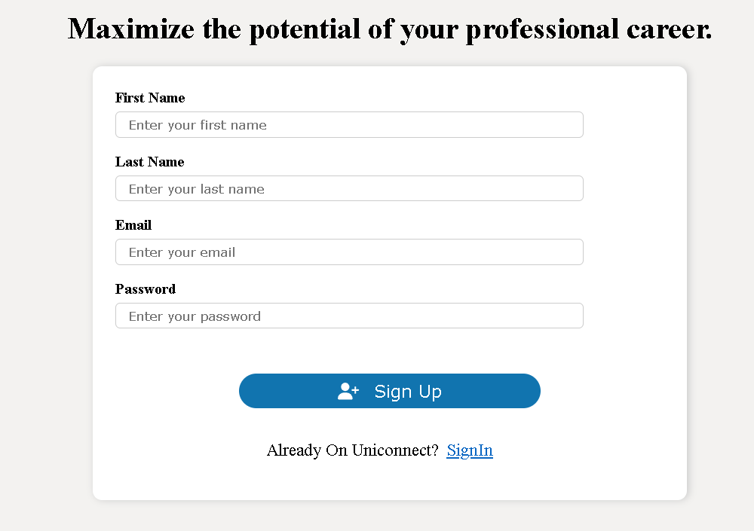

1. **Dashboard:**

**Feature:**

* A menu-driven dashboard with options such as "Home," "Events," "Messages," and "Profile."
* Includes event summaries and upcoming event notifications in widgets.

**Justification:**

* Enhances usability by supporting **retention over time** through consistent menu placement and **speed of operation** via easily accessible widgets.

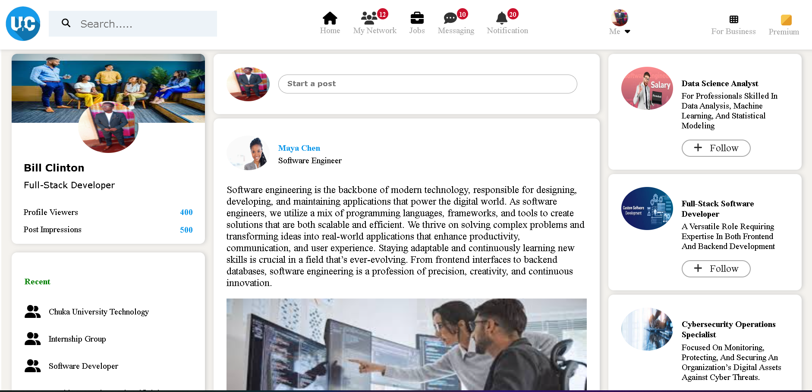

1. **Search Functionality:**

**Feature:**

* A natural language search bar that allows users to search for events using plain language queries.
* Displays results dynamically below the search bar.

**Justification:**

* Promotes **subjective satisfaction** and reduces cognitive load, making it accessible even for non-technical users.



**Implementation Notes:**

* **Responsive Design**: The UI adapts seamlessly to both mobile and desktop screens.
* **Error Handling**: Real-time validation minimizes error rates, with clear error messages displayed.

**Conclusion:**

The prototyped UI design prioritizes usability, ensuring it meets critical attributes such as **time to learn**, **retention over time**, **error rate**, **speed of operation**, and **subjective satisfaction**. The screenshots provided illustrate the implemented features and their contribution to an efficient and user-friendly interface. Future improvements could include integrating advanced analytics to customize user experiences further.